SUBHARAM GOVT DEGREE COLLEGE
PUNGANUR
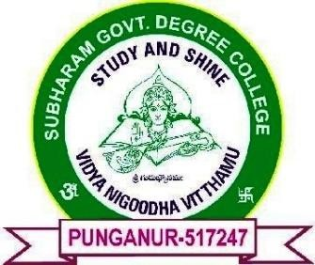
Affiliated to S V University Mob No: +91 9885876776
NAAC Grade “B” [CGPA 2.18] Email: punganur.jkc@gmail.com
ISO Certification 9001:2015 Web: www.srgdcpunganur.ac.in
Punganur, Chittoor District
Andhra Pradesh – 517247

6.1.1 The governance and leadership is in accordance with vision and mission of the institution and it is visible in various institutional practices such as decentralization and participation in the institutional governance

Metric No | Si No | Title | Link
6.1.1 | 1 | Vision, Mission | 
6.1.1 | 2 | Organogram | 
6.1.1 | 3 | Committees | 

